PROJECT REPORT
SMARTINTERNZ
VIRTUAL INTERNSHIP
ON
GOOGLE CLOUD GENERATIVE AI
PROJECT NAME: AI GENERATED ITINERARY
BY
DUDDIKUNTA SUSMITHA
TEAM ID: LTVIP2026TMIDS70981

Submitted By:
Duddikunta Susmitha
23785A3306
Under the Guidance of: SmartInternz
Sri Venkateswara College of Engineering and Technology

Your College Name: Sri Venkateswara College of Engineering and Technology
Date of Submission: 19-02-2026

1.INTRODUCTION
1.1 Project Overview
The Travel Guide AI project is an intelligent, AI-powered travel planning and recommendation system designed to simplify and enhance the travel planning process for users. With the rapid growth of tourism and increasing demand for personalized travel experiences, travelers often struggle to plan trips efficiently due to the overwhelming amount of information available across multiple platforms. This project addresses that challenge by offering a centralized, smart solution that automates itinerary creation and provides customized travel recommendations. Travel Guide AI leverages Artificial Intelligence, Machine Learning, and Natural Language Processing (NLP) techniques to analyze user preferences such as destination, travel duration, budget, interests, and accommodation type. Based on these inputs, the system generates personalized travel itineraries that include recommended tourist attractions, travel routes, accommodation options, and activity schedules. The system aims to reduce manual effort while improving decision accuracy and user satisfaction.
The project is developed as a web-based application with a user-friendly interface that allows users to interact seamlessly with the AI system. The backend processes user inputs, applies intelligent recommendation algorithms, and retrieves relevant travel data from datasets or APIs. The output is presented in a structured and visually clear format, enabling users to easily understand and follow the suggested itinerary. Travel Guide AI is not limited to individual travelers; it can also be beneficial for travel agencies, tour operators, and tourism departments by enabling them to generate high-quality itineraries quickly and efficiently. By automating the travel planning workflow, the system helps optimize time, cost, and resource utilization.
1.2 Purpose
The primary purpose of the Travel Guide AI project is to design and develop an intelligent system that simplifies the travel planning process by providing personalized, accurate, and efficient travel recommendations. Traditional trip planning involves extensive research, comparison of options, and manual scheduling, which is time-consuming and often confusing for travelers. This project aims to eliminate these challenges by automating itinerary generation using Artificial Intelligence.Another key purpose of this project is to enhance user experience by delivering customized travel plans based on individual preferences. By analyzing user inputs such as budget constraints, travel interests, and duration, the system ensures that the recommendations align closely with user expectations. This level of personalization helps travelers make informed decisions and enjoy a more satisfying travel experience.
The project also aims to reduce the dependency on multiple travel websites and platforms by providing a unified solution for travel planning. By consolidating essential travel information such as destinations, attractions, accommodations, and routes into a single platform, Travel Guide AI improves accessibility and usability. From an academic and technical perspective, the purpose of this project is to demonstrate the effective use of AI, machine learning, and recommendation systems in a real-world application. The project provides hands-on experience in designing intelligent systems, implementing backend logic, integrating APIs, and managing databases.

2. IDEATION PHASE
The ideation phase plays a crucial role in identifying the core problem, understanding user needs, and generating effective solutions for the Travel Guide AI project. This phase focuses on analyzing real-world challenges faced by travelers and designing an intelligent system that addresses those challenges through user-centric design and innovative thinking. By applying ideation techniques such as problem analysis, empathy mapping, and brainstorming, the foundation for a meaningful and efficient travel planning solution is established.
2.1 Problem Statement
In today’s digital era, travelers rely heavily on online platforms to plan their trips. However, travel planning remains a complex and time-consuming process due to the availability of vast, unorganized, and often inconsistent information spread across multiple websites and applications. Travelers must manually search for destinations, compare accommodations, check transportation options, estimate budgets, and plan daily itineraries, which leads to confusion and decision fatigue.
Most existing travel platforms provide generic recommendations that fail to consider individual preferences such as travel interests, budget constraints, duration, and personal priorities. As a result, users often receive irrelevant suggestions that do not align with their expectations. Additionally, travelers with limited experience may struggle to create optimized itineraries, leading to inefficient time management and increased travel costs.
There is a need for an intelligent system that can analyze user preferences and automatically generate personalized travel itineraries. Such a system should reduce manual effort, eliminate information overload, and provide accurate, customized recommendations in a single platform. The absence of a smart, user-centric travel planning solution forms the core problem addressed by the Travel Guide AI project.
2.2 Empathy Map Canvas
The Empathy Map Canvas is used to understand the users’ experiences, emotions, and expectations. It helps in designing a solution that aligns with real user needs.
What the User Thinks
- Wants a quick and easy way to plan trips
- Needs trustworthy travel recommendations
- Prefers personalized itineraries over generic plans
What the User Feels
- Overwhelmed by too many online travel options
- Frustrated by time-consuming planning
- Anxious about budget and scheduling issues
What the User Says
- “I want everything in one place”
- “Planning a trip takes too much time”
- “I need suggestions based on my budget and interests”
What the User Does
- Searches multiple travel websites
- Reads reviews and compares prices manually
- Modifies travel plans repeatedly
By understanding these user behaviors and emotions, Travel Guide AI is designed to provide a simplified, intelligent, and personalized travel planning experience that minimizes user effort and maximizes satisfaction.
2.3 Brainstorming
Brainstorming was conducted to generate innovative ideas and identify possible features for the Travel Guide AI system. The focus was on solving user problems effectively using Artificial Intelligence.
Key ideas generated during brainstorming include:
- AI-based personalized itinerary generation
- Preference-driven destination and attraction recommendations
- Budget-optimized travel plans
- Intelligent scheduling of daily activities
- User-friendly web interface
- Centralized travel planning platform
- Scalable system architecture for future enhancements
These ideas were evaluated based on feasibility, user impact, and technical complexity. The most practical and valuable ideas were selected for implementation, forming the foundation of the Travel Guide AI solution.

3. REQUIREMENT ANALYSIS
The requirement analysis phase of the Travel Guide AI (Travel Itinerary Generator) project focuses on understanding the user interaction flow, identifying system requirements, defining data movement, and selecting suitable technologies. The system is designed as a simple, form-based AI application that allows users to generate travel itineraries instantly without authentication. The frontend emphasizes ease of use, minimal inputs, and fast itinerary generation.
3.1 Customer Journey Map
The customer journey map explains how a user interacts with the Travel Guide AI application from start to finish.
- Opening the Application
The user accesses the Travel Itinerary Generator through a web browser running on a local or deployed server. No login or registration is required.
- Entering Destination
The user enters the desired travel destination (e.g.,remembered pilgrimage places, tourist cities, or vacation spots) into the destination input field.
- Selecting Number of Days
The user specifies the number of days for the trip using a numeric input control, ensuring accurate trip duration.
- Selecting Number of Nights
The user enters the number of nights corresponding to the travel plan. This helps the system align accommodation and daily planning.
- Generating Itinerary
The user clicks the Generate Itinerary button to submit the inputs.
- AI Processing and Output Display
The backend processes the inputs and generates a structured travel itinerary, which is displayed on the same interface for user review.
This journey ensures quick access, minimal effort, and instant results, making the system suitable for all types of users.
3.2 Solution Requirement
The solution requirements define what the system should do (functional) and how well it should perform (non-functional).
Functional Requirements
- Text input for travel destination
- Numeric input for number of days
- Numeric input for number of nights
- Button to trigger itinerary generation
- AI-based itinerary generation logic
- Display of generated itinerary on the frontend
- Ability to regenerate itinerary by changing inputs
Non-Functional Requirements
- Usability: Simple and clean user interface
- Performance: Fast response time for itinerary generation
- Reliability: Consistent itinerary output for given inputs
- Scalability: Ability to handle multiple users when deployed
- Accessibility: Web-based access from any device
3.3 Data Flow Diagram
The Data Flow Diagram (DFD) describes how data flows through the Travel Guide AI system.
- The user enters destination, number of days, and number of nights
- Input data is sent from the frontend to the backend
- The AI itinerary generation logic processes the inputs
- Relevant travel information is generated dynamically
- The final itinerary is sent back to the frontend
- The generated travel plan is displayed to the user
This streamlined data flow ensures efficient processing and real-time itinerary generation.
3.4 Technology Stack
The Travel Guide AI project uses the following technology stack based on the implemented frontend:
- Frontend Framework: Streamlit
- Backend Language: Python
- AI Logic: Rule-based itinerary generation / AI text generation
- Input Components: Streamlit text and number input widgets
- Output Display: Dynamic text rendering in Streamlit
- Development Environment: VS Code
- Execution Environment: Localhost / Cloud deployment
This technology stack enables rapid development, interactive UI design, and easy deployment.

4. PROJECT DESIGN
The Project Design phase defines how the Travel Guide AI system is structured to solve the identified problem. It explains how the proposed solution aligns with user needs and describes the system architecture that enables itinerary generation. The design ensures simplicity, usability, and efficiency while maintaining scalability for future improvements.
4.1 Problem–Solution Fit
The primary problem identified during the ideation phase was the complexity and time consumption involved in travel planning. Users often spend hours researching destinations, planning daily activities, managing travel duration, and organizing accommodations. Additionally, many platforms provide generic recommendations that do not fully align with user preferences.
The Travel Guide AI system provides a direct and simplified solution to this problem by:
- Allowing users to input only essential travel details (destination, number of days, number of nights)
- Automatically generating a structured travel itinerary
- Reducing the need for manual research
- Delivering instant, organized results
The system ensures that minimal user input produces meaningful and structured travel plans. The frontend is intentionally designed to be clean and distraction-free, making it easy for users of any technical background to interact with the application. By integrating AI-based itinerary generation logic with a simple interface, the solution effectively addresses the core issue of time-consuming and complicated travel planning. Thus, there is a strong alignment between the identified problem and the proposed solution, confirming a clear problem–solution fit.
4.2 Proposed Solution
The proposed solution is a web-based AI Travel Itinerary Generator built using Python and Streamlit. The system generates a day-wise travel plan based on user inputs.
Key Features of the Proposed Solution:
- Simple Input Interface
  - Destination input field
  - Number of days selection
  - Number of nights selection
  - “Generate Itinerary” button
- AI-Based Itinerary Generation
  - The system processes user inputs
  - It dynamically creates a day-wise travel plan
  - The itinerary includes suggested places and activities
- Instant Output Display
  - The generated itinerary is displayed immediately on the same page
  - The output is structured and easy to read
- Regeneration Option
  - Users can modify input values and generate a new itinerary instantly
The solution eliminates unnecessary complexity such as login systems, booking modules, or multi-step navigation. Instead, it focuses on delivering a core functionality — generating an efficient travel plan quickly and effectively.
4.3 Solution Architecture
The architecture of the Travel Guide AI system follows a simple yet effective structure consisting of three main layers:
1. Presentation Layer (Frontend)
- Built using Streamlit
- Contains input fields for destination, days, and nights
- Displays generated itinerary
- Handles user interaction
This layer is responsible for collecting user inputs and displaying outputs clearly.
2. Application Layer (Backend Logic)
- Implemented using Python
- Contains itinerary generation logic
- Processes user inputs
- Structures output into day-wise travel plans
This layer acts as the core processing unit of the system.
3. AI / Itinerary Generation Module
- Uses rule-based logic or AI text generation
- Creates structured itinerary based on:
  - Destination
  - Trip duration
- Generates dynamic day-wise travel suggestions
This module ensures personalization and automation.
Architectural Flow
- User enters travel details
- Streamlit frontend captures inputs
- Inputs are passed to Python backend
- AI logic generates itinerary
- Output is returned to frontend
- Final travel plan is displayed
This architecture ensures:
- Fast processing
- Minimal latency
- Easy scalability
- Simple deployment
Design Advantages
- Lightweight architecture
- Easy to maintain
- No complex authentication system
- Quick deployment using Streamlit
- User-friendly interaction

5. PROJECT PLANNING & SCHEDULING
Project Planning and Scheduling is an essential phase that outlines how the Travel Guide AI project was organized, executed, and monitored. This phase ensures that the project is completed within the given time frame while meeting the defined objectives. Proper planning helps in efficient resource utilization, risk management, and systematic development of the application.
The Travel Guide AI project was planned in a structured manner, dividing the entire development process into multiple phases. Each phase focuses on specific tasks such as requirement analysis, design, development, testing, and deployment. This approach ensures smooth workflow and timely completion of the project.
5.1 Project Planning
The project planning phase involved identifying tasks, defining timelines, and allocating responsibilities for the development of the Travel Guide AI system. Since the project is a web-based AI application, emphasis was placed on simplicity, accuracy, and usability.
Project Phases and Activities
- Requirement Analysis
  - Understanding the project objectives
  - Analyzing user interaction based on the frontend
  - Identifying functional and non-functional requirements
- System Design
  - Designing frontend layout using Streamlit
  - Planning input and output flow
  - Designing solution architecture
- Development Phase
  - Implementing Streamlit frontend
  - Writing backend logic in Python
  - Implementing itinerary generation logic
- Testing Phase
  - Functional testing of input fields
  - Validation of itinerary generation
  - Performance testing for response time
- Deployment
  - Running the application on localhost
  - Optional cloud deployment using Streamlit Cloud
Resource Planning
- Human Resource: Single developer / student
- Software Tools: Python, Streamlit, VS Code
- Hardware Requirements:
  - Minimum 4GB RAM
  - Any modern web browser
Risk Management
- Incorrect itinerary generation
- Input validation issues
- Performance delays
These risks were minimized by testing input constraints and validating outputs.
Monitoring and Control
Progress was monitored after completion of each phase. Any issues identified during testing were corrected before proceeding to the next phase. This ensured continuous improvement and quality assurance.

6. FUNCTIONAL AND PERFORMANCE TESTING
Testing is a crucial phase in the development of the Travel Guide AI system. It ensures that the application functions correctly, meets user requirements, and performs efficiently under different conditions. The testing phase verifies both the functional aspects (what the system does) and the performance aspects (how well the system performs).
For the Travel Itinerary Generator, testing focused on validating user inputs, itinerary generation logic, response time, and overall system reliability.
6.1 Functional Testing
Functional testing ensures that all features of the application work according to the defined requirements. Each component of the Travel Guide AI system was tested individually and collectively.
1. Input Field Testing
- Verified that the destination text field accepts valid location names.
- Checked that numeric input fields accept only numbers.
- Ensured that negative or invalid values are not processed.
- Tested behavior when input fields are left empty.
Result:
All input fields function correctly and handle invalid inputs appropriately.
2. Button Functionality Testing
- Verified that clicking the “Generate Itinerary” button triggers backend processing.
- Ensured that the button does not produce errors when valid inputs are provided.
- Tested multiple clicks to ensure stable performance.
Result:
The button successfully initiates itinerary generation without system crashes.
3. Itinerary Generation Testing
- Tested different destinations (e.g., pilgrimage sites, tourist cities).
- Tested various combinations of days and nights.
- Verified that the output is structured in a day-wise format.
- Ensured that the itinerary corresponds to the selected duration.
Result:
The system generates structured and readable itineraries based on user inputs.
4. Regeneration Testing
- Changed inputs after generating an itinerary.
- Verified that the system updates and generates a new travel plan.
Result:
The application successfully regenerates itineraries without errors.
6.2 Performance Testing
Performance testing evaluates how efficiently the system responds under normal usage conditions. Since the Travel Guide AI application runs using Streamlit and Python, testing focused on speed, responsiveness, and stability.
1. Response Time Testing
- Measured the time taken from clicking “Generate Itinerary” to displaying the result.
- Observed system behavior for different input combinations.
Observation:
The system generates results within a few seconds under normal conditions.
2. Load Handling
- Tested the application by repeatedly generating itineraries.
- Simulated multiple executions during runtime.
Observation:
The system performs consistently without significant delay when handling repeated requests.
3. Stability Testing
- Ran the application continuously for extended periods.
- Checked for crashes or unexpected behavior.
Observation:
The system remains stable and does not crash during continuous use.
4. Input Validation Performance
- Tested edge cases such as:
  - Very high number of days
  - Zero or empty inputs
- Verified that the system handles these cases properly.
Observation:
The application manages edge cases effectively and prevents invalid processing.

7.RESULTS
7.1 Input Screenshots
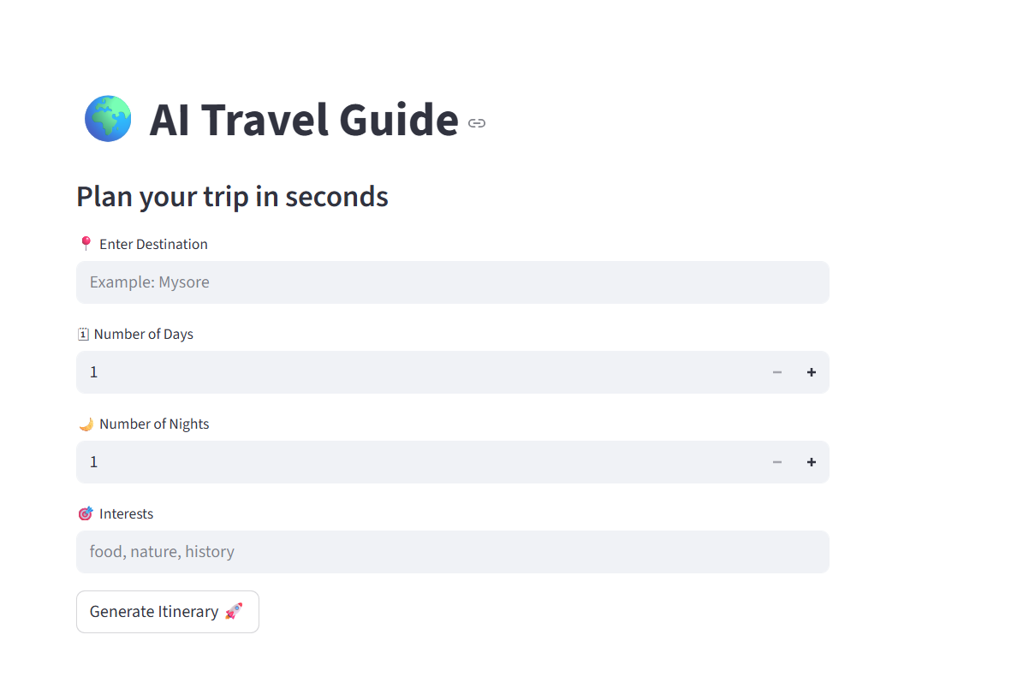
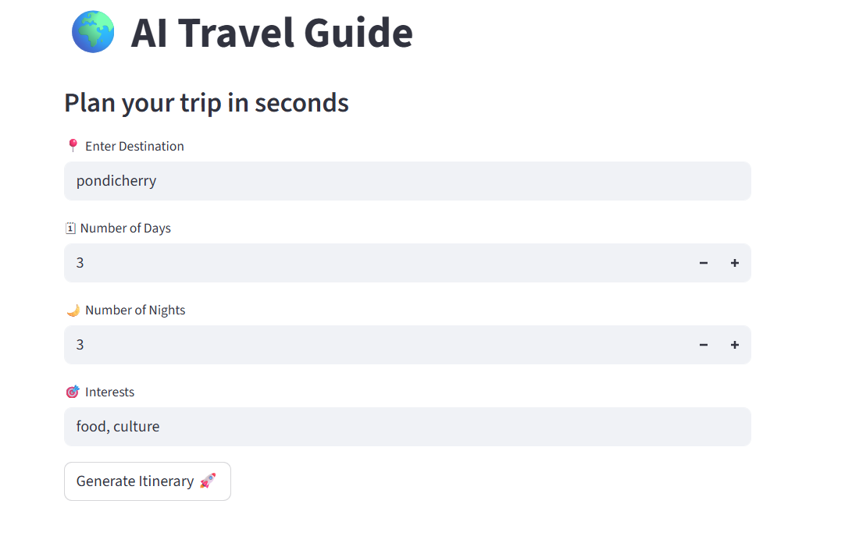

7.2 Output Screenshots
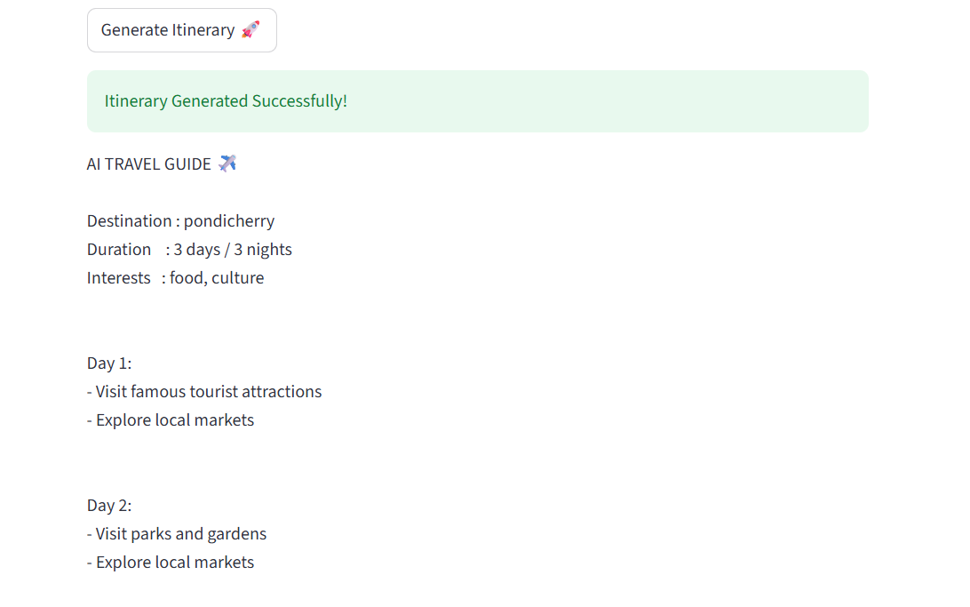



8. ADVANTAGES & DISADVANTAGES
This section highlights the strengths and limitations of the Travel Guide AI system. Understanding both aspects helps evaluate the effectiveness of the solution and identify areas for improvement.
8.1 Advantages
- Simple and User-Friendly Interface
The application provides a clean and minimal interface that allows users to generate travel itineraries easily without any technical knowledge.
- No Login or Registration Required
Users can access the system directly, saving time and eliminating the complexity of authentication.
- Time-Saving Travel Planning
The AI system generates structured travel itineraries instantly, reducing the need for manual research.
- Efficient Itinerary Generation
Based on destination, days, and nights, the system produces organized day-wise travel plans.
- Web-Based Accessibility
The application can be accessed through any modern web browser, making it convenient for users.
- Scalable Architecture
The system design allows future enhancements such as additional features and integrations.
- Low Development and Deployment Cost
Using Streamlit and Python reduces development complexity and deployment cost.
8.2 Disadvantages
- Limited Personalization
The current version uses basic inputs and does not include advanced preference selection such as food, budget categories, or travel style.
- Internet Dependency
The application requires an active internet connection to function properly.
- No Real-Time Data Integration
The system does not currently provide live updates such as weather conditions or crowd levels.
- No Booking Integration
Users cannot directly book hotels or transportation through the system.
- Static Itinerary Logic
The itinerary generation is rule-based and can be enhanced with advanced AI models.

9. CONCLUSION
The Travel Guide AI project successfully demonstrates the application of Artificial Intelligence in simplifying travel planning. The system provides an efficient, user-friendly solution that generates structured travel itineraries based on minimal user input. By eliminating the need for login and reducing complex interactions, the application ensures quick and easy access for users.
The project effectively addresses the challenges associated with traditional travel planning, such as time consumption and information overload. The use of Streamlit and Python enables rapid development, interactive user experience, and easy deployment. Functional and performance testing confirmed that the system operates reliably and efficiently.
Overall, the Travel Guide AI project meets its objectives by delivering a practical and intelligent travel itinerary generator. It serves as a strong foundation for further enhancements and demonstrates the potential of AI-driven solutions in the tourism and travel domain.

10. FUTURE SCOPE
The Travel Guide AI system can be enhanced further by incorporating advanced features and technologies. Possible future improvements include:
- Advanced Personalization
Adding preferences such as budget range, food choices, travel interests, and accommodation type.
- AI Chatbot Integration
Introducing a conversational AI assistant to interact with users and refine travel plans.
- Real-Time Data Integration
Integrating live weather updates, traffic conditions, and local events.
- Booking and Payment Integration
Allowing users to book hotels, transportation, and activities directly from the platform.
- Multi-Language Support
Expanding accessibility by supporting multiple languages.
- Mobile Application Development
Developing a mobile-friendly or standalone mobile application version.
- Recommendation System Enhancement
Using machine learning models for more accurate and dynamic itinerary recommendations.
11. APPENDIX
app.py
import streamlit as st
from itinerary_generator import generate_itinerary
st.set_page_config(page_title="AI Travel Guide", page_icon="✈️")
st.title("Travel GuideAI - Itinerary Generator")
st.subheader("Plan your trip in seconds")
destination = st.text_input(" Enter Destination", placeholder="Example: Mysore")
days = st.number_input(" Number of Days", min_value=1, max_value=15, step=1)
nights = st.number_input(" Number of Nights", min_value=1, max_value=15, step=1)
interests = st.text_input(" Interests", placeholder="food, nature, history")
if st.button("Generate Itinerary "):
if destination and interests:
result = generate_itinerary(destination, days, nights, interests)
st.success("Itinerary Generated Successfully!")
st.text(result)
else:
st.warning("Please fill all fields.")

GitHub & Project Demo Link
https://github.com/Susmitha570/Travel-Guide.git

